**It’s windy**

What’s the weather like today?

* It’s thunder and lighting

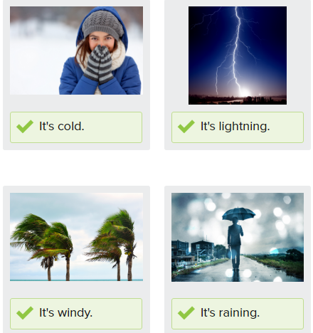

What’s the weather like?

* It’s hot

I like to wear a warm hat when it’s snowing

I like to go to the beach when it’s sunny

When it’s raining, I take an umbrella

It’s thundering and lightning outside. It is best to stay at home

What weather do you like?

* I like sunny/rainy/windy weather

**Countable vs Uncountable**

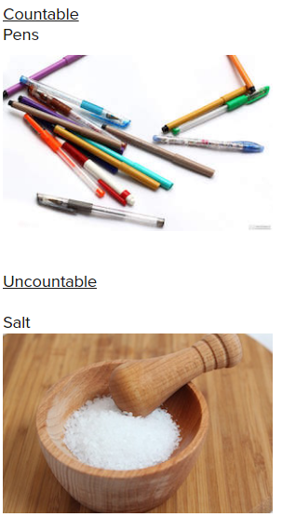

**Short Answers**

Is he tall?

* Yes, he is. /No. He isn’t

Is she nice?

* Yes, she is./No, she isn’t

Are you happy?

* Yes. I am / no, I’m not

Are you portuguese?

* Yes, I am

Is Simon a j Japanese student?

* No, he isn’t

Are you an office worker?

* No, I’m not

Is your wife at the hotel?

* Yes, she is

Is Pat a businesswoman?

* No, she isn’t

Are you merried?

* Yes, I am

Is your husband American?

* Yes, he is